Order form of the Fibre Microscopy Atlas

Microscopy in forensic fibre examinations
A practical photo atlas and training tool

Order information
Date | DD/MM/2021 |  | Order/invoice number | leave empty
I confirm the order of # copy/ies. This/these book(s) should be shipped to:
Full name (first and surname)
Company name | Affiliation | Institution | Private use
Full postal adress for shipping
Street and House number
or Post office box
City, State and Zip code
Country
Customer contact information
Phone nr, incl. country code
E-mail adress
Remarks
Please be sure to fill out all fields marked in orange. Thank you!

Product information  • hardcover and bounded atlas (A4 size)  • 420 pages, glossy print  • over 250 high-quality, colour printed fibre images  • contains chapters on Low Power Microscopy, Bright Field Microscopy, Polarization Microscopy, Fluorescence Microscopy, Comparison Microscopy and Training in Fibre Microscopy  • with fibre identification tables for man-made, vegetable and animal fibres  • with multiple choice questions and additional fibre images for training purposes  Price  The Fibre Microscopy Atlas is Delivered Duty Paid (DDP shipping) for all customers: taxes, shipping expenses and customs clearance are all included in the price. Therefore, two different prices are set: for customers within and outside Europe.  Thank you for your understanding. | 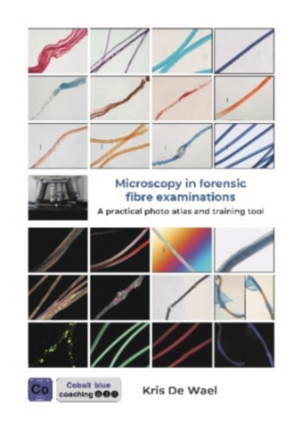  € 195,00 * | € 225,00 **  DELIVERED DUTY PAID  * within Europe  (EU + non-EU countries)  ** outside Europe
Purchase procedure
• Please fill out all customer information fields marked in orange on this order form and send this order to: info@cobaltbluecoaching.be

• You will receive an order confirmation and invoice with payment instructions.

• Your copy/ies of the Fibre Microscopy Atlas is/are shipped after receiving payment.

